NEELKANTH INSTITUTION OF ENGINEERING AND TECHNOLOGY MEERUT
A
Project Report
On
Hospital Bed Management System (NGI-Meerut)
Submitted as a partial fulfilment of the requirements for the award of the degree of

Diploma
In
Computer Science & Engineering


Submitted By:
Abhinav Singwal

Anil Kumar

Under the Guidance of Mrs. Esha Papdeja



DEPARTMENT OF COMPUTER SCEINCE AND ENGINEERING
Neelkanth Institute of Technology [U.P.]
(Approved by affiliated to Board Of Technical University Lucknow U.P)
DECLARATION
I hereby declare that this submission is my own work and that, to the best of my knowledge and belief, it contains no material previously published or written by another person nor material which to a substantial extent has been accepted for the award of any other degree or diploma of the university or other institute of higher learning, except where due acknowledgment has been made in the text.
Signature

Name: Abhinav Singwal
Enrollment No.:E1616135500001

Signature

Name: Anil Kumar
Enrollment No.: E1616135500003
CERTIFICATE

This is to certify that this project entitled “Hospital Bed Management System” submitted by Abhinav Singwal (E1616135500001), Anil Kumar (E1616135500003), students of Computer Science and Engineering Department, Neelkanth Institute of Engineering Technology, Meerut in the partial fulfilment of the requirement for the award of Bachelors of Technology (Computer Science & Engineering) Diploma of BTEUP, Lucknow, is a record of students own study carried under my supervision & guidance.

This report has not been submitted to any other university or institution for the award of any deploma.

Mrs. Esha papdeja
H.O.D
Department of CSE
NIET, Meerut

ACKNOWLEDGEMENT
Signature

Name: Abhinav Singwal
Enrollment No.:E1616135500001

Signature

Name: Anil Kumar
Enrollment No.:E1616135500003

ABSTRACT
Any task in the world cannot be accomplished on a sole basis. It directly or indirectly needs the overt or covert support of their acquaintances, beloved ones or their faculty heads. We have culminated our project with the aid of not only our friends but the assistance provided by our faculties cannot be neglected.
Thus, we would like to give a sincere thanks to my institute "Neelkanth Institute of Technology, Meerut" for providing me the platform in which we have put my raw knowledge of concepts to an implementation level. The facility of internet provided us with the ease which helped us to reach the implementation level fast.
We would like to honours for the incredible support he gave us. He fostered and encouraged us to pursue it to finish it to the rising stars. His motivation acted as strength for us.
Our acknowledgement cannot be complete without mentioning this name who have not only support us but also showered their experience drops on our project which makes it embellish and a full fledge technology. Being a project head, Mrs. Esha Papdeja, and being a guide,they delegated their knowledge to us which helped us to learn a lot.
A special thanks to all faculty members who were keen to respond our queries. Last but not least support of our colleagues cannot be snubbed.

A computer program is a set of instructions which solves our problems. In this computer program I try to solve problems and try to think better solutions for my problem. A computer program is a solution of a specific problem which we face in real world. computer program is a solution that makes our work easy and fast. In our world there are many computer programming languages I choose java for my project. Java is a Hybrid, portable, object oriented language.
The number of hospital beds is a significant constraint on the operation of healthcare services because it receives demands from various areas and requires larger volumes to implement and maintain. The theory of constraints (TOC) seeks to map and act on constraints, thereby contributing to the mitigation of waste and the root causes of undesirable effects . This project presents a study of a large hospital that aims to improve the management of the number of hospital beds using the Program. The method was exploratory and descriptive; it focused on applying the current reality tree to alleviate the UEs related to the low availability of hospital beds. The primary results promote a greater understanding of the present problems in the management of hospital beds and serve as a basis for future work to improve healthcare services.

TABLE OF CONTENTS

LIST OF TABLES v

CHAPTER 1: INTRODUCTION 1
1.1 Problem Statement 1
1.2 Purpose 2
1.3 Structure 4
1.4 Project Scope 5
1.5 Synopsis………………………………………………………………………………………….5

CHAPTER 2: SYSTEM DESCRIPTION 6
2.1 Technology Used ( java ) 6
2.2 Tools Used 7
2.2.1 JDK 7
2.2.2 Mysql 9
2.2.3 Notepad 10
2.2.4 JVM 11
2.3 OOPS 11

CHAPTER 3: MODULE DESCRIPTION 13
3.1 System Design 13
3.2 Logical Design 13
3.3 Physical Design 13
3.4 SDLC Model 14
3.6 Hardware Requirements 19
3.7 Software Requirement Specification 19

CHAPTER 4: ANALYSIS 20
4.1 Feasibility Study 20
4.1.1 Technical Feasibility 20
4.1.2 Economic Feasibility 21
4.1.3 Behavioral Feasibility 21
4.2 User Characteristics 21

CHAPTER 5: SYSTEM DESIGN 22
5.1 General Information…………………………………………………………………………….22
5.2 Software Design 27
5.2.1 Coding 28
5.2.2 Create Hospital Object 48
5.2.3 Create Ward 48
5.2.4 Need Beds 48
5.2.5 Shift Beds 48

5.3 Design Strategy 49
5.3.1 JAVA 49
5.3.2 Object Oriented Design 49
5.4 Database ……………………… ……………………………………………………………50

CHAPTER 6: TESTING 53
6.1 What is Testing?
6.2 Levels of Testing?

CHAPTER 7: SCREENSHOTS 55

CHAPTER 8: CONCLUSION & FUTURE SCOPE 60

CHAPTER 9: REFERENCE 61

CHAPTER 1
INTRODUCTION
A computer program is a collection of instructions that performs a specific task when executed by a computer. A computer requires programs to function. A computer program is usually written by a computer programmer in a programming language. From the program in its human-readable form of source code, a compiler can derive machine code—a form consisting of instructions that the computer can directly execute. Alternatively, a computer program may be executed with the aid of an interpreter.

A collection of computer programs, libraries, and related data are referred to as software. Computer programs may be categorized along functional lines, such as application software and system software. The underlying method used for some calculation or manipulation is known as an algorithm.

Computer programming is the process of writing or editing source code. Editing source code involves testing, analyzing, refining, and sometimes coordinating with other programmers on a jointly developed program. A person who practices this skill is referred to as a computer programmer, software developer, and sometimes coder.

The sometimes lengthy process of computer programming is usually referred to as software development. The term software engineering is becoming popular as the process is seen as an engineering discipline.

Object-oriented programming (OOP) is a programming paradigm based on the concept of "objects", which can contain data, in the form of fields (often known as attributes), and code, in the form of procedures (often known as methods). A feature of objects is an object's procedures that can access and often modify the data fields of the object with which they are associated (objects have a notion of "this" or "self"). In OOP, computer programs are designed by making them out of objects that interact with one another. OOP languages are diverse, but the most popular ones are class-based, meaning that objects are instances of classes, which also determine their types.

Java is a programming language and computing platform first released by Sun Microsystems in 1995. There are lots of applications and websites that will not work unless you have Java installed, and more are created every day. Java is fast, secure, and reliable. From laptops to datacenters, game consoles to scientific supercomputers, cell phones to the Internet, Java is everywhere!

Java Swing is a lightweight Graphical User Interface (GUI) toolkit that includes a rich set of widgets. It includes package lets you make GUI components for your Java applications, and It is platform independent.
The Swing library is built on top of the Java Abstract Widget Toolkit (AWT), an older, platform dependent GUI toolkit. You can use the Java GUI components like button, textbox, etc. from the library and do not have to create the components from scratch.

  - Problem Statement

Bed management is the allocation and provision of beds, especially in a hospital where beds in specialist wards are a scarce resource. The "bed" in this context represents not simply a place for the patient to sleep, but the services that go with being cared for by the medical facility: admission processing, physician time, nursing care, necessary diagnostic work, appropriate treatment, and so forth.

In the UK, acute hospital bed management is usually performed by a dedicated team and may form part of a larger process of patient flow management.

Shortage of beds due to lack of other options. Hospitals in developed countries cannot force a patient to leave if the patient's home is reasonably believed to be unsafe. For example, if a frail, elderly patient has recovered from an acute illness, but is unable to dress himself and prepare simple meals on his own, then the hospital must ensure that the patient will have sufficient assistance with these necessary activities of daily living, or the patient must remain in the hospital. In places with a shortage of skilled nursing facilities, home health care workers, and related support organizations, beds may be unavailable for new, acutely sick patients because of the continued presence of the previous patients. This is sometimes known as a "bed blocking".

False appearance or unnecessary creation of a bed shortage. "Bed hiding", as it is sometimes called, is the practice of delaying admissions due to a falsely claimed lack of beds in the appropriate department. Bed hiding has several causes, including scheduling so many elective procedures that there are inadequate beds left for emergency admissions; frequent changes from ward to ward; inadequate communication, so that cleaning staff don't know when a bed has become available and needs cleaning; misalignment of tasks, so that skilled nurses are expected to take time away from direct patient care to clean beds; too few nurses scheduled for a shift; and overworked staff, who may be inclined to mis-report a bed as full, especially at the end of a shift, in an effort to shift the workload to another person. Bed hiding can be significantly reduced by careful tracking of bed status, making cleaning after discharge the top priority for cleaning staff, and even by physically moving patients to the ward as soon as they are ready for admission rather than boarding them in the emergency department. Reducing bed hiding in regular wards can reduce wait times in the emergency department.

  - Purpose

The lack of adequate numbers of hospital beds to accommodate the injured is a main problem in public hospitals. For control of occupancy of bed, we design a dynamic system that announces status of bed when it change with admission or discharge of a patient. This system provide a wide network in country for bed management, especially for ICU and CCU beds that help us to distribute injured patient in the hospitals.

BM forms an important part of operational capacity planning and control, a wider activity concerned with the efficient use of resources. Outside the health context, the production/operations function of an organisation is concerned with activities such as scheduling and work flow to enable throughput to meet demand, and minimise work in progress and maximise resource utilisation. Despite the obvious analogies, very few acute hospitals have an operations management function.

Bed managers place emergency admissions (via A&E, MAU, transfers from other hospitals and, in some trusts, handle urgent referral telephone calls from GPs) and elective admissions (although not in all trusts3), attempting to accommodate to come in (TCI) lists. In some trusts, patients outlying on inappropriate wards (particularly medical patients on surgical wards) may be transferred to another ward, in others this is not the case as it is considered disruptive (a widely quoted figure is that a move will add a day to a patient’s length of stay6). Discharge involves coordinating many services the patient may require, from the pharmacy and transport to care packages provided by agencies outside the trust. Despite great potential to contribute to capacity planning and crisis avoidance, in practice BM is often characterised by bed finding, and firefighting once a crisis is occurring.3,7

  - Structure

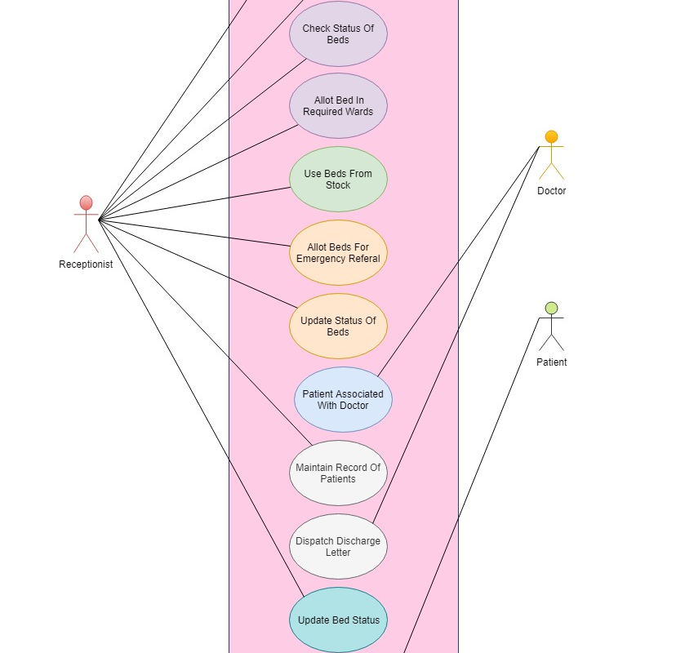

  - Project Scope

- This program provides a easy bed management structure.
- This system also provides availability of beds in every ward.
- It also provides a well handled every ward and beds in hospital.
- It provides the current status of every ward.
- adjusting working practices to better match the general patterns
- operational planning to anticipate day to day supply and demand, together with the capability to take steps to attempt to match them.
- Hospital Bed Management System is a very common problem in each hospital, I hope our management software will be useful.
- In many hospitals there are no have any functionality to operate beds in hospital so this system make a free bed management functionality and this system is very easy to operate.

  - Synopsis
Hospital bed management system is a functionality to operate beds in different wards. Each Ward in hospitals has some beds and these beds used by peoples, when these beds are free these are totally unusable then we can find a new way to use these beds.
CHAPTER 2
SYSTEM DESCRIPTION
2.1 Technology Used
JAVA: Programming Interface
Java is a general-purpose programming language that is class-based, object-oriented, and designed to have as few implementation dependencies as possible. It is intended to let application developers "write once, run anywhere" (WORA), meaning that compiled Java code can run on all platforms that support Java without the need for recompilation. Java applications are typically compiled to "bytecode" that can run on any Java virtual machine (JVM) regardless of the underlying computer architecture. The syntax of Java is similar to C and C++, but it has fewer low-level facilities than either of them. As of 2018, Java was one of the most popular programming languages in use according to GitHub, particularly for client-server web applications, with a reported 9 million developers.

Java was originally developed by James Gosling at Sun Microsystems (which has since been acquired by Oracle) and released in 1995 as a core component of Sun Microsystems' Java platform. The original and reference implementation Java compilers, virtual machines, and class libraries were originally released by Sun under proprietary licenses. As of May 2007, in compliance with the specifications of the Java Community Process, Sun had relicensed most of its Java technologies under the GNU General Public License. Meanwhile, others have developed alternative implementations of these Sun technologies, such as the GNU Compiler for Java (bytecode compiler), GNU Classpath (standard libraries), and IcedTea-Web (browser plugin for applets).
The latest version is Java SE 12, released in March 2019. Since Java 9 is no longer supported, Oracle advises its users to "immediately transition" to Java 12. Oracle released the last public update for the legacy Java 8 LTS, which is free for commercial use, in January 2019. Java 8 will be supported with public updates for personal use up to at least December 2020. Oracle and others "highly recommend that you uninstall older versions of Java"[21] because of serious risks due to unresolved security issues. Oracle extended support for Java 6 ended in December 2018.
Types of Java Applications
There are mainly 4 types of applications that can be created using Java programming:
1) Standalone Application
Standalone applications are also known as desktop applications or window-based applications. These are traditional software that we need to install on every machine. Examples of standalone application are Media player, antivirus, etc. AWT and Swing are used in Java for creating standalone applications.
2) Web Application
An application that runs on the server side and creates a dynamic page is called a web application. Currently, Servlet, JSP, Struts, Spring, Hibernate, JSF, etc. technologies are used for creating web applications in Java.

3) Enterprise Application
An application that is distributed in nature, such as banking applications, etc. is called enterprise application. It has advantages of the high-level security, load balancing, and clustering. In Java, EJB is used for creating enterprise applications.

4) Mobile Application
An application which is created for mobile devices is called a mobile application. Currently, Android and Java ME are used for creating mobile applications.

2.2 Tools Used

2.2.1 Java Development Kit
The Java Development Kit (JDK) is an implementation of either one of the Java Platform, Standard Edition, Java Platform, Enterprise Edition, or Java Platform, Micro Edition platforms[1] released by Oracle Corporation in the form of a binary product aimed at Java developers on Solaris, Linux, macOS or Windows. The JDK includes a private JVM and a few other resources to finish the development of a Java Application. Since the introduction of the Java platform, it has been by far the most widely used Software Development Kit (SDK).[citation needed] On 17 November 2006, Sun announced that they would release it under the GNU General Public License (GPL), thus making it free software. This happened in large part on 8 May 2007, when Sun contributed the source code to the OpenJDK.
The JDK has as its primary components a collection of programming tools, including:

appletviewer – this tool can be used to run and debug Java applets without a web browser
apt – the annotation-processing tool[4]
extcheck – a utility that detects JAR file conflicts
idlj – the IDL-to-Java compiler. This utility generates Java bindings from a given Java IDL file.
jabswitch – the Java Access Bridge. Exposes assistive technologies on Microsoft Windows systems.
java – the loader for Java applications. This tool is an interpreter and can interpret the class files generated by the javac compiler. Now a single launcher is used for both development and deployment. The old deployment launcher, jre, no longer comes with Sun JDK, and instead it has been replaced by this new java loader.
javac – the Java compiler, which converts source code into Java bytecode
javadoc – the documentation generator, which automatically generates documentation from source code comments
jar – the archiver, which packages related class libraries into a single JAR file. This tool also helps manage JAR files.
javafxpackager – tool to package and sign JavaFX applications
jarsigner – the jar signing and verification tool
javah – the C header and stub generator, used to write native methods
javap – the class file disassembler
javaws – the Java Web Start launcher for JNLP applications
JConsole – Java Monitoring and Management Console
jdb – the debugger
jhat – Java Heap Analysis Tool (experimental)
jinfo – This utility gets configuration information from a running Java process or crash dump. (experimental)
jmap Oracle jmap - Memory Map– This utility outputs the memory map for Java and can print shared object memory maps or heap memory details of a given process or core dump. (experimental)
jmc – Java Mission Control
jps – Java Virtual Machine Process Status Tool lists the instrumented HotSpot Java Virtual Machines (JVMs) on the target system. (experimental)
jrunscript – Java command-line script shell.
jshell - The new jshell introduced in java 9.
jstack – utility that prints Java stack traces of Java threads (experimental)
jstat – Java Virtual Machine statistics monitoring tool (experimental)
jstatd – jstat daemon (experimental)
keytool – tool for manipulating the keystore
pack200 – JAR compression tool
policytool – the policy creation and management tool, which can determine policy for a Java runtime, specifying which permissions are available for code from various sources.
VisualVM – visual tool integrating several command-line JDK tools and lightweight[clarification needed] performance and memory profiling capabilities
wsimport – generates portable JAX-WS artifacts for invoking a web service.
xjc – Part of the Java API for XML Binding (JAXB) API. It accepts an XML schema and generates Java classes.
2.2.2 Mysql
MySQL is an open-source relational database management system (RDBMS). Its name is a combination of "My", the name of co-founder Michael Widenius's daughter, and "SQL", the abbreviation for Structured Query Language.

MySQL is free and open-source software under the terms of the GNU General Public License, and is also available under a variety of proprietary licenses. MySQL was owned and sponsored by the Swedish company MySQL AB, which was bought by Sun Microsystems (now Oracle Corporation). In 2010, when Oracle acquired Sun, Widenius forked the open-source MySQL project to create MariaDB.

MySQL is a component of the LAMP web application software stack (and others), which is an acronym for Linux, Apache, MySQL, Perl/PHP/Python. MySQL is used by many database-driven web applications, including Drupal, Joomla, phpBB, and WordPress.

MySQL is also used by many popular websites, including Facebook, Twitter, Flickr, and YouTube.

2.2.3 Notepad

Notepad is a simple text editor for Microsoft Windows and a basic text-editing program which enables computer users to create documents. It was first released as a mouse-based MS-DOS program in 1983, and has been included in all versions of Microsoft Windows since Windows 1.0 in 1985.

2.2.4 JVM

JVM (Java Virtual Machine) is an abstract machine. It is a specification that provides runtime environment in which java bytecode can be executed.
JVMs are available for many hardware and software platforms (i.e. JVM is platform dependent).
A specification where working of Java Virtual Machine is specified. But implementation provider is independent to choose the algorithm. Its implementation has been provided by Oracle and other companies.
An implementation Its implementation is known as JRE (Java Runtime Environment).
Runtime Instance Whenever you write java command on the command prompt to run the java class, an instance of JVM is created.

2.3 OOPS (Object Oriented Programming)

Object-oriented programming (OOP) refers to a type of computer programming (software design) in which programmers define not only the data type of a data structure, but also the types of operations (functions) that can be applied to the data structure.

In this way, the data structure becomes an object that includes both data and functions. In addition, programmers can create relationships between one object and another. For example, objects can inherit characteristics from other objects.

The Basic OOP Concepts

If you are new to object-oriented programming languages, you will need to know a few basics before you can get started with code. The following Webopedia definitions will help you better understand object-oriented programming:

Abstraction: The process of picking out (abstracting) common features of objects and procedures.

Class: A category of objects. The class defines all the common properties of the different objects that belong to it.

Encapsulation: The process of combining elements to create a new entity. A procedure is a type of encapsulation because it combines a series of computer instructions.

Information hiding: The process of hiding details of an object or function. Information hiding is a powerful programming technique because it reduces complexity.

Inheritance: a feature that represents the "is a" relationship between different classes.
Interface: the languages and codes that the applications use to communicate with each other and with the hardware.

Messaging: Message passing is a form of communication used in parallel programming and object-oriented programming.

Object: a self-contained entity that consists of both data and procedures to manipulate the data.

Polymorphism: A programming language's ability to process objects differently depending on their data type or class.

Procedure: a section of a program that performs a specific task.

Advantages of Object Oriented Programming

One of the principal advantages of object-oriented programming techniques over procedural programming techniques is that they enable programmers to create modules that do not need to be changed when a new type of object is added. A programmer can simply create a new object that inherits many of its features from existing objects. This makes object-oriented programs easier to modify.

OOPL - Object Oriented Programming Languages

An object-oriented programming language (OOPL) is a high-level programming language based on the object-oriented model. To perform object-oriented programming, one needs an object-oriented programming language. Many modern programming languages are object-oriented, however some older programming languages, such as Pascal, do offer object-oriented versions. Examples of object-oriented programming languages include Java, C++ and Smalltalk.

CHAPTER 3

MODULE DESCRIPTION

3.1. System Design

Design is the first step into the development phase for any engineered product or system. Design is a creative process. A good design is the key to effective system. The term “design” defined as a process of applying
is defined as “the process of applying various techniques and principles for the purpose of
defining a process or a system in sufficient detail to permit its physical realization”. It may be
various techniques and principles for the purpose of defining a device, a process or a system in sufficient

a device, a process or a system in sufficient detail to permit its physical realization. Software design sits

at the technical kernel of the software engineering process and is applied regardless of the development paradigm that is used. The system design develops the architectural detail required to build a system or product. As in the case of any systematic approach, this software too has undergone the best possible design phase fine tuning all The design phase is a transition from a user oriented document to a document to the programmers or database personnel.

System design goes through two phases of development:

- Logical Design and
- Physical Design

3.2. Logical Design

The logical flow of a system and define the boundaries of a system. It includes the following steps :

- Reviews the current physical system - its data flows, file content, volumes, frequencies etc.

- Prepares output specifications - that is,determines the format, content and frequency of reports.

- Prepares input specifications , format, content and most of the input functions.

- Prepares edit, security and control specifications.

- Specifies the implementation plan.

- Prepares a logical design walk through of the information flow, output, input, controls and implementation plan.

- Reviews benefits, costs, target dates and system constraints.

3.3. Physical Design

Physical system produces the working systems by define the design specifications that tell the
programmers exactly what the candidate system must do. It includes the following steps.

- Design the physical system.

- Specify input and output media.

- Design the database and specify backup procedures.

- Design physical information flow through the system and a physical design Walk through.

- Plan system implementation.

- Prepare a conversion schedule and target date.

- Determine training procedures, courses and timetable.

- Devise a test and implementation plan and specify any new hardware/software.

- Update benefits, costs, and conversion date and system constraints.

3.4. SDLC Model
The Software Development Lifecycle is a systematic process for building software that ensures the quality and correctness of the software built. SDLC process aims to produce high-quality software which meets customer expectations. The software development should be complete in the pre-defined time frame and cost.
SDLC consists of a detailed plan which explains how to plan, build, and maintain specific software. Every phase of the SDLC lifecycle has its own process and deliverables that feed into the next phase. phase of the SDLC lifecycle has its own process and deliverables that feed into the next phase.

Why SDLC?
Here, are prime reasons why SDLC is important for developing a software system.
- It offers a basis for project planning, scheduling, and estimating
- Provides a framework for a standard set of activities and deliverables
- It is a mechanism for project tracking and control
- Increases visibility of project planning to all involved stakeholders of the development process
- Increased and enhance development speed
- Improved client relations
- Helps you to decrease project risk and project management plan overhead.

The entire SDLC process divided into the following stages:

- Phase 1: Requirement collection and analysis:
- Phase 2: Feasibility study:
- Phase 3: Design:
- Phase 4: Coding:
- Phase 5: Testing:
- Phase 6: Installation/Deployment:
- Phase 7: Maintenance:
Spiral Model
This project is based on Spiral SDLC model because Spiral Model is a combination of a waterfall model and iterative model. Each phase in spiral model begins with a design goal and ends with the client reviewing the progress.

Use cases for the Spiral model
- Customer isn’t sure about the requirements.
- Major edits are expected during the development cycle.
- The projects with mid or high-level risk, where it is important to prevent these risks.
- The new product that should be released in a few stages to have enough of clients feedback.

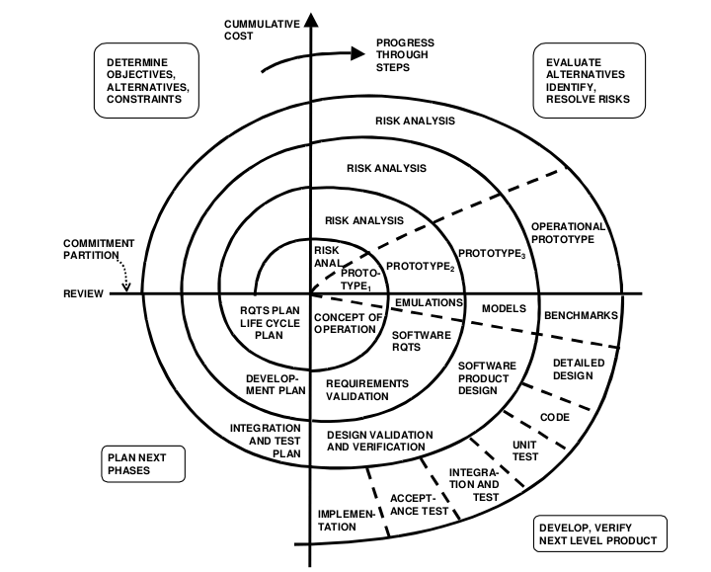

Spiral Model Phases
Spiral Model Phases | Activities performed during phase
Planning | - It includes estimating the cost, schedule and resources for the iteration. It also involves understanding the system requirements for continuous communication between the system analyst and the customer
Risk Analysis | - Identification of potential risk is done while risk mitigation strategy is planned and finalized
Engineering | - It includes testing, coding and deploying software at the customer site
Evaluation | - Evaluation of software by the customer. Also, includes identifying and monitoring risks such as schedule slippage and cost overrun

3.5 Hardware Requirements:

Processor : Intel Pentium IV 2.0 GHz and above

RAM : 8 MB and above

Hard disk : 80GB and above

Monitor : CRT or LCD monitor

Keyboard : Normal or Multimedia

Mouse : Compatible mouse

3.6 Software Requirements:

Front End : JAVA

Language : JAVA

Back End : MYSQL

Operation System : Windows XP or above

CHAPTER 4
ANALYSIS
4.1 Feasibility Study
Feasibility study is made to see if the project on completion will serve the purpose of the organization for the amount of work, effort and the time that spend on it. Feasibility study lets the developer foresee the future of the project and the usefulness. A feasibility study of a system proposal is according to its work ability, which is the impact on the organization, ability to meet their user needs and effective use of resources. Thus when a new application is proposed it normally goes through a feasibility study before it is approved for development.
The document provide the feasibility of the project that is being designed and lists various areas that were considered very carefully during the feasibility study of this project such as Technical, Economic and Operational feasibilities. The following are its features:

4.1.1 Technical Feasibility
The system must be evaluated from the technical point of view first. The assessment of this feasibility must be based on an outline design of the system requirement in the terms of input, output, programs and procedures. Having identified an outline system, the investigation must go onto suggest the type of equipment, required method developing the system, of running the system once it has been designed.
Technical issues raised during the investigation are:

      - Does the existing technology sufficient for the suggested one?
      - Can the system expand if developed?
The project should be developed such that the necessary functions and performance are achieved within the constraints. The project is developed within latest technology. Through the technology may become obsolete after some period of time, due to the fact that never version of same software supports older versions, the system may still be used. So there are minimal constraints involved with this project. The system has been developed using Java the project is technically feasible for development.
We as Analysts have identified the existing computer systems (hardware & software) of the concerned department and have determined whether these technical resources are sufficient for the proposed system or not. We have found out thus, that the project is technically very much feasible. The hardware and software requirements are:
IDE: Netbeans

Operating system: Any as Windows, Linux.

4.1.2 Economic feasibility

The developing system must be justified by cost and benefit. Criteria to ensure that effort is concentrated on project, which will give best, return at the earliest. One of the factors, which affect the development of a new system, is the cost it would require.
The following are some of the important financial questions asked during preliminary investigation:
      - The costs conduct a full system investigation.
      - The cost of the hardware and software.
      - The benefits in the form of reduced costs or fewer costly errors.

Since the system is developed as part of project work, there is no manual cost to spend for the proposed system. Also all there sources are already available, it give an indication of the system is economically possible for development.

4.1.3 Behavioural Feasibility

This includes the following questions:

- Is there sufficient support for the users?
- Will the proposed system cause harm?

The project would be beneficial because it satisfies the objectives when developed and installed. All behavioural aspects are considered carefully and conclude that the project is behaviourally feasible.

4.2 User Characteristics:

User: User can select any type of file for the purpose of compression or decompression, to send it over the network with greater speeds.

End Users:
1.) He must know to how to operate the software.
2.) He must have basic knowledge of computer.

CHAPTER 5

SYSTEM DESIGN

5.1 General Information

In this software we used many functions, classes, data structures and many oops concepts to solve our problems. We are use data structures algorithms to save our information, before sql language computer programmers used data structures to save software information. What is a Function? - A function is a block of organized, reusable code that is used to perform a single, related action. Functions provide better modularity for your application and a high degree of code reusing. You have already seen various functions like println() and main(). These are called built-in functions provided by the language itself, but we can write our own functions as well and this tutorial will teach you how to write and use those functions in java programming language. Similarly classes are the blueprint of our objects and data structures used to store our data in a specific manner.

We are discussing some main functions and classes in our software here –

Classes

Hospital class –

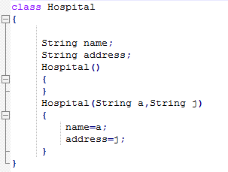

Hospital class is the super class of our computer program because according to the oops our main object is Hospital so that here we are using hospital as a Super class. In hospital class we are using many variables and constructors to handle data values. When we execute our program the hospital class run firstly. Shown as figure-

according to the program you have to enter your Hospital name firstly ( in my case AIIMS ) then you have to write the address of the hospital and then that data will be store in String name, String address variables.

2. Ward Class

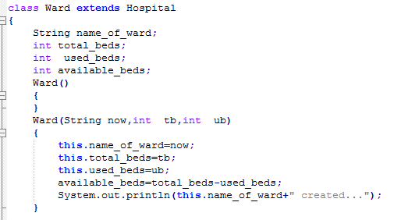

Ward class is child class of Hospital class. It is a very important class in our computer program. According to oops, Ward class extending Hospital class because Ward is a sub-category of Hospitals. In Ward class there are many functions to handle our ward status and information about it.

3. Test Class

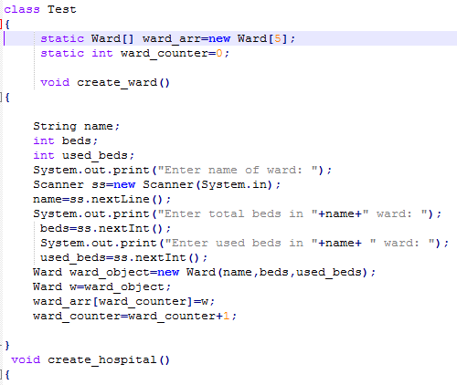

Functions

1.need_bed_main function

If we need a bed then we have to call this function. need_bed function need a parameter value according to needs of beds.if beds are not available then this function has a condition to handle this type of difficulty.

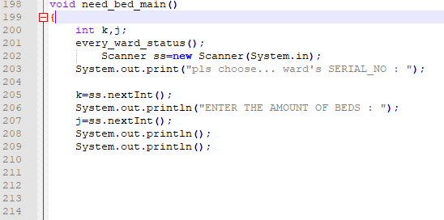

2.release_bed function

This function have to use if we want to release a bed. We can also release many beds at one time.

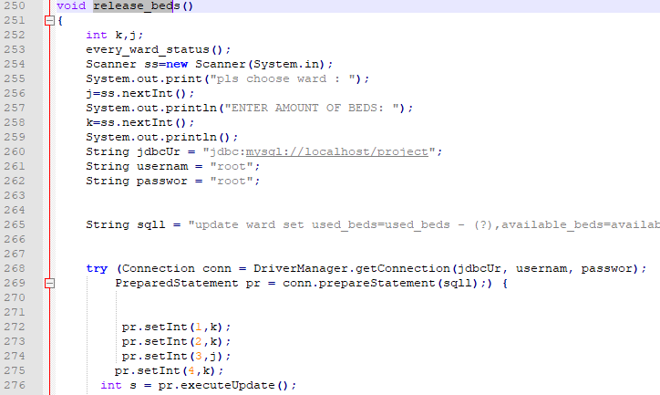

create_ward function
This is a void datatype function and function use to create a ward like – emergency ward, cardiology ward etc. this function stores data in a arry of every ward.

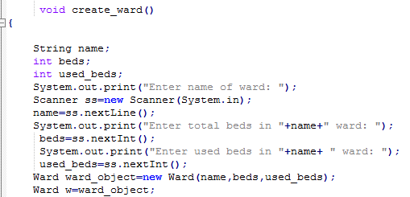

create_hospital function

this function is used to create a hospital object and store value in hospital class.

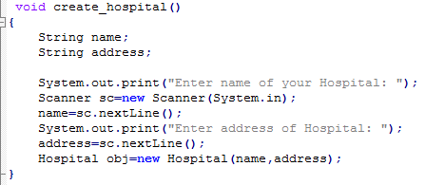

every_ward_status()
This function disply status of every ward. This is a void type function that used to display information. This function contains for loop that displays every ward status in a sequence manner.

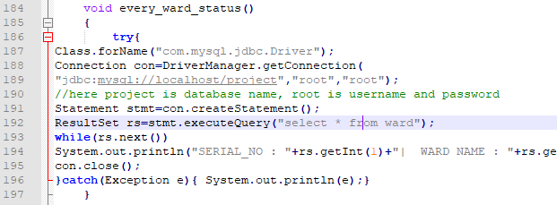

shift_beds function

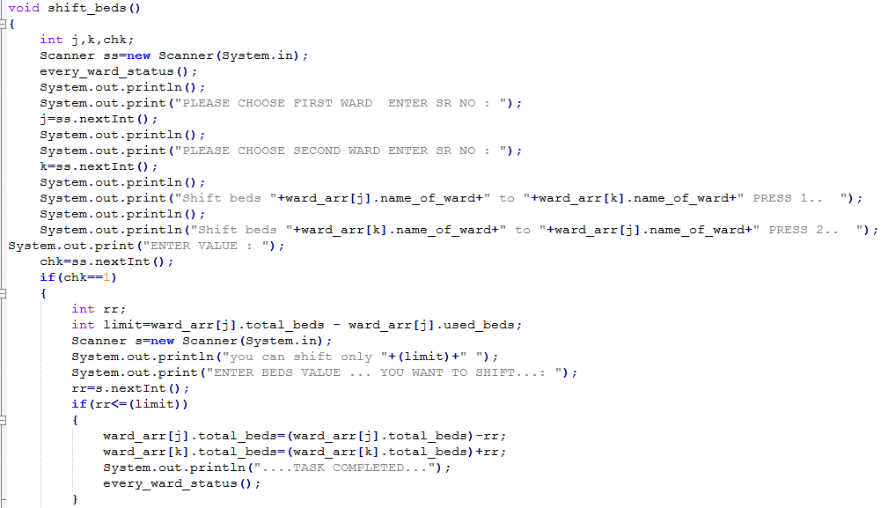

This function is designed to shift beds in different wards.

5.2 Software Design

We use object oriented programming concept to design our computer program and use data structures to handle the data. We have create many classes, constructors, functions and arrays to handle information and transfer data to one object to another object. Our software design is written in java language with oops and mysql.

5.2.1 Coding

Based on the software design document the work is aiming to set up the defined modules or units and actual coding is started. The system is first developed in smaller portions called units. They are able to stand alone from a functional aspect and are integrated later on to form the complete software package.

/*
* HOSPITAL BED MANAGEMENT SYSTEM
* FILE NAME :Test.java
* FRONT END : JAVA
* BACK END : MYSQL
* DESIGN : DESIGNED IN OOPS
* CODING : ABHINAV SINGWAL AND ANIL KUMAR

*/

import java.util.*; //IMPORTING PACKAGES
import java.sql.*;

/*
* HOSPITAL CLASS IS THE SUPER CLASS OF HOSPITAL BED MANAGEMENT SYSTEM

* HOSPITAL CLASS CONTAINS NAME AND ADDRESS VARIABLES.
*/
class Hospital
{

String name;
String address;
Hospital()
{
}
Hospital(String a,String j)
{
name=a;
address=j;
}
}

/*
* WARD CLASS IS SUB CLASS OF HBMS.
* THIS CLASS CONTAINS MANY VARIABLES LIKE: WARD NAME, USED BEDS, TOTAL BEDS ETC.
* THIS CLASS IS USED TO CREATE WARDS
*/
class Ward extends Hospital
{
String name_of_ward;
int total_beds;
int used_beds;
int available_beds;
Ward()
{
}
Ward(String now,int tb,int ub)
{
this.name_of_ward=now;
this.total_beds=tb;
this.used_beds=ub;
available_beds=total_beds-used_beds;
System.out.println(this.name_of_ward+" created...");
}

public void need_bed(int value)
{

if(value>this.available_beds)
{
int y;
Scanner rr=new Scanner(System.in);
System.out.println("beds not availabe");

}
else
{
this.used_beds=this.used_beds+value;
this.available_beds=this.total_beds-this.used_beds;
System.out.println("ok.. now total available beds "+this.available_beds);
}
}

public void release_bed(int value)
{
if(value>this.used_beds)
{
System.out.println("wrong value");
}
else
{
this.used_beds=this.used_beds-value;
this.available_beds=this.total_beds=this.used_beds;
System.out.println("release operation sucessful");

}
}
}
/*
TEST CLASS IS THE DRIVER CLASS OF OUR PROGRAM

* IN THIS CLASS. WE ESTABLASHED DATABASE CONNECTIVITY WITH MYSQL DATABASE
* TEST CLASS CARRY MANY FUNCTIONS LIKE NEED BEDS, RELEASE BEDS ETC
* TEST CLASS CONTAINS MENU FUNCTION
*
*/
class Test
{
static Ward[] ward_arr=new Ward[10];
static int ward_counter=0;

void create_ward()
{

String name;
int beds;
int used_beds;
System.out.print("Enter name of ward: ");
Scanner ss=new Scanner(System.in);
name=ss.nextLine();
System.out.print("Enter total beds in "+name+" ward: ");
beds=ss.nextInt();
System.out.print("Enter used beds in "+name+ " ward: ");
used_beds=ss.nextInt();
Ward ward_object=new Ward(name,beds,used_beds);
Ward w=ward_object;
ward_arr[ward_counter]=w;
ward_counter=ward_counter+1;
try
{
try
{
Class.forName("com.mysql.jdbc.Driver");
}
catch(ClassNotFoundException ce)

{
System.out.println("Loading driver failed");
}

Connection conn = DriverManager.getConnection("jdbc:mysql://localhost/project","root","root");
String sql="insert into ward(wname,total_beds,used_beds,available_beds) values(?,?,?,?)";
PreparedStatement st = conn.prepareStatement(sql);

st.setString(1,name);
st.setString(2,Integer.toString(beds));
st.setString(3,Integer.toString(used_beds));
st.setString(4,Integer.toString(beds-used_beds));
st.executeUpdate();
}
catch(Exception ae)
{
System.out.println("Something might be wrong");
}

}
void create_hospital()
{
String name;
String address;

System.out.print("Enter name of your Hospital: ");
Scanner sc=new Scanner(System.in);
name=sc.nextLine();
System.out.print("Enter address of Hospital: ");
address=sc.nextLine();
Hospital obj=new Hospital(name,address);
try
{
try
{
Class.forName("com.mysql.jdbc.Driver");
}
catch(ClassNotFoundException ce)

{
System.out.println("Loading driver failed");
}

Connection conn = DriverManager.getConnection("jdbc:mysql://localhost/project","root","root");
String sql="insert into hospital(hname,hadd) values(?,?)";
PreparedStatement st = conn.prepareStatement(sql);
st.setString(1,name);
st.setString(2,address);
st.executeUpdate();
}
catch(Exception ae)
{
System.out.println("Something might be wrong");
}
}
void every_ward_status()
{
try{
Class.forName("com.mysql.jdbc.Driver");
Connection con=DriverManager.getConnection(
"jdbc:mysql://localhost/project","root","root");
//here sonoo is database name, root is username and password
Statement stmt=con.createStatement();
ResultSet rs=stmt.executeQuery("select * from ward");
while(rs.next())
System.out.println("SERIAL_NO : "+rs.getInt(1)+"| WARD NAME : "+rs.getString(2)+"| TOTAL BEDS : "+rs.getInt(3)+"| USED BEDS : "+rs.getInt(4)+"| AVAILABLE BEDS : "+rs.getInt(5));
con.close();
}catch(Exception e){ System.out.println(e);}
}
void need_bed_main()
{
int k,j;
every_ward_status();
Scanner ss=new Scanner(System.in);
System.out.print("pls choose... ward's SERIAL_NO : ");

k=ss.nextInt();
System.out.println("ENTER THE AMOUNT OF BEDS : ");
j=ss.nextInt();
System.out.println();
System.out.println();

String jdbcUrl = "jdbc:mysql://localhost/project";
String username = "root";
String password = "root";

String sql = "update ward set used_beds =used_beds + (?),available_beds =available_beds-(?) where id = (?) AND available_beds> (?)";

try (Connection conn = DriverManager.getConnection(jdbcUrl, username, password);
PreparedStatement pr = conn.prepareStatement(sql);) {

pr.setInt(1,j);
pr.setInt(2,j);
pr.setInt(3,k);
pr.setInt(4,j);
int s = pr.executeUpdate();

} catch (SQLException e) {
e.printStackTrace();
}

}
void release_beds()
{
int k,j;
every_ward_status();
Scanner ss=new Scanner(System.in);
System.out.print("pls choose ward : ");
j=ss.nextInt();
System.out.println("ENTER AMOUNT OF BEDS: ");
k=ss.nextInt();
System.out.println();
String jdbcUr = "jdbc:mysql://localhost/project";
String usernam = "root";
String passwor = "root";

String sqll = "update ward set used_beds=used_beds - (?),available_beds=available_beds+(?) where id = (?) AND used_beds>=(?)";

try (Connection conn = DriverManager.getConnection(jdbcUr, usernam, passwor);
PreparedStatement pr = conn.prepareStatement(sqll);) {

pr.setInt(1,k);
pr.setInt(2,k);
pr.setInt(3,j);
pr.setInt(4,k);
int s = pr.executeUpdate();

} catch (SQLException e) {
e.printStackTrace();
}

}
int menu()
{
int flag;
System.out.print("CREATE WARD... press 0... " );
System.out.println("NEED BEDS... press 8.... ");
System.out.print("EXIT... press 5.... ");
System.out.println("All wards status...press 4..");
System.out.print("SHIFT BEDS... PRESS 7..... ");
System.out.println("CLEAR SCREEN ... PRESS 9...");
System.out.print("RELEASE BEDS... PRESS 2..... ");
System.out.println(" UPDATE WARD VALUES... press 1.... ");
System.out.println();
System.out.print("PLEASE ENTER VALUE : ");
Scanner sc=new Scanner(System.in);
flag=sc.nextInt();
return flag;

}
void shift_beds()
{
int j,k,chk;
Scanner ss=new Scanner(System.in);
every_ward_status();
System.out.println();
System.out.print("PLEASE CHOOSE FIRST WARD ENTER SR NO : ");
j=ss.nextInt();
System.out.println();
System.out.print("PLEASE CHOOSE SECOND WARD ENTER SR NO : ");
k=ss.nextInt();
System.out.println();
System.out.print("Shift beds UPPER WARD TO LOWER WARD ... PRESS 2.. ");
System.out.println();
System.out.println("Shift beds LOWER WARD TO UPPER WARD ... PRESS 1.. ");
System.out.print("ENTER VALUE : ");
chk=ss.nextInt();
System.out.println("AMOUNT OF BEDS.. YOU WANNA SHIFT.. : ");
int amount=ss.nextInt();
if(chk==1)
{

String jdbcUrl = "jdbc:mysql://localhost/project";
String username = "root";
String password = "root";

String sql = "update ward set total_beds=total_beds + (?),available_beds=available_beds+(?) where id = (?) AND available_beds>=(?)";

try (Connection conn = DriverManager.getConnection(jdbcUrl, username, password);
PreparedStatement pr = conn.prepareStatement(sql);) {

pr.setInt(1,amount);
pr.setInt(2,amount);
pr.setInt(3,j);
pr.setInt(4,amount);

int s = pr.executeUpdate();

} catch (SQLException e) {
e.printStackTrace();
}

String jdbcUr = "jdbc:mysql://localhost/project";
String usernam = "root";
String passwor = "root";

String sqll = "update ward set total_beds=total_beds - (?),available_beds=available_beds-(?) where id = (?) AND available_beds>=(?)";

try (Connection conn = DriverManager.getConnection(jdbcUr, usernam, passwor);
PreparedStatement pr = conn.prepareStatement(sqll);) {

pr.setInt(1,amount);
pr.setInt(2,amount);
pr.setInt(3,k);
pr.setInt(4,amount);
int s = pr.executeUpdate();

} catch (SQLException e) {
e.printStackTrace();
}
}
else if(chk==2)
{
String jdbcUrl = "jdbc:mysql://localhost/project";
String username = "root";
String password = "root";

String sql = "update ward set total_beds=total_beds + (?),available_beds=available_beds+(?) where id = (?) AND available_beds>=(?)";

try (Connection conn = DriverManager.getConnection(jdbcUrl, username, password);
PreparedStatement pr = conn.prepareStatement(sql);) {

pr.setInt(1,amount);
pr.setInt(2,amount);
pr.setInt(3,k);
pr.setInt(4,amount);
int s = pr.executeUpdate();

} catch (SQLException e) {
e.printStackTrace();
}

String jdbcUr = "jdbc:mysql://localhost/project";
String usernam = "root";
String passwor = "root";

String sqll = "update ward set total_beds=total_beds - (?),available_beds=available_beds-(?) where id = (?) AND available_beds>=(?)";

try (Connection conn = DriverManager.getConnection(jdbcUr, usernam, passwor);
PreparedStatement pr = conn.prepareStatement(sqll);) {

pr.setInt(1,amount);
pr.setInt(2,amount);
pr.setInt(3,j);
pr.setInt(4,amount);
int s = pr.executeUpdate();

} catch (SQLException e) {
e.printStackTrace();
}
}
else{
System.out.println("enter a valid value : ");
}
}
public void update_ward()
{
String rname;
Scanner sc=new Scanner(System.in);
Scanner ss=new Scanner(System.in);
every_ward_status();
System.out.println();
System.out.println();
System.out.print("please enter SERIAL NO. you wanna update : ");
int j=sc.nextInt();
System.out.print("ok...");
System.out.println();
System.out.println("ward name : ");
rname=ss.nextLine();
System.out.println("enter total beds : ");
int tot=sc.nextInt();
System.out.println("enter used beds :");
int use=sc.nextInt();
int av=tot-use;
String jdbcUr = "jdbc:mysql://localhost/project";
String usernam = "root";
String passwor = "root";

String sqll = "update ward set wname=(?),total_beds=(?),used_beds=(?),available_beds=(?) where id = (?)";

try (Connection conn = DriverManager.getConnection(jdbcUr, usernam, passwor);
PreparedStatement pr = conn.prepareStatement(sqll);) {

pr.setString(1,rname);
pr.setInt(2,tot);
pr.setInt(3,use);
pr.setInt(4,av);
pr.setInt(5,j);
int s = pr.executeUpdate();

} catch (SQLException e) {
e.printStackTrace();
}
}
public static void main(String args[])
{

Test obj=new Test();

int check=1;
while(true)
{
check=obj.menu();
switch(check)
{
case 0:
obj.create_ward();

break;
case 1:
obj.update_ward();
break;
case 8:
obj.need_bed_main();

break;
case 2:
obj.release_beds();
break;
case 5:

break;
case 4:
obj.every_ward_status();
break;
case 9:
for (int i = 0; i < 50; ++i) System.out.println();

break;
case 7:
obj.shift_beds();
break;
default:
System.out.println("wrong value:");

}
if(check==5)
{

break;
}

}

}
}

5.2.3 Create Ward

We know that every hospital has many ward to handle different diseases. In our program you have to create many wards according to your hospital and have to store data about your wards like- total beds in your ward and used beds in your ward.

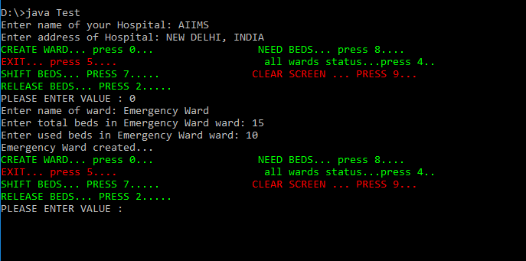

5.2.4 Needs Beds:

In emergency we need beds then enter your beds requirement and click enter ..

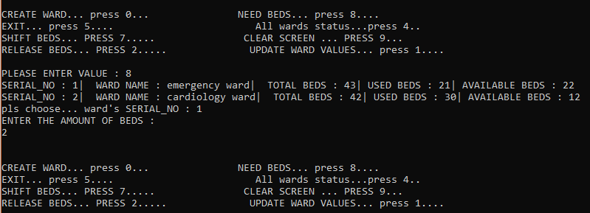

5.3 Design Strategy:

A good system design strategy is to organize the program modules in such a way that are easy to develop and later to, change. Structured design techniques help developers to deal with the size and complexity of programs. Analysts create instructions for the developers about how code should be written and how pieces of code should fit together to form a program. It is important for two reasons:
    - First, even pre-existing code, if any, needs to be understood, organized and pieced together.
    - Second, it is still common for the product team to have to write some code and produce original programs that support the application logic of the system.
There are two main design strategies: Top-down and Bottom-up strategies.
Bottom-Up

In our project we follow bottom up design strategy because we are aware of the modules of our project and we decide how to combine these modules to provide larger ones; to combine those to even larger ones and soon, till we arrive at one big module which is the whole of the desired program.
In a bottom-up approach the individual base elements of the system are first specified in great detail. These elements are then linked together to form larger subsystems, which then in turn are linked, sometimes in many levels, until a complete top-level system is formed. This strategy often resembles a "seed" model, whereby the beginnings are small, but eventually grow in complexity and completeness.

5.3.2 Object Oriented Design
Object oriented design is the result of focusing attention not on the function performed by the program but instead on the data that are to be manipulated by the program. We use java technology as the base technology for our project which follows principles of OOPS (Object-oriented programming system). Object-oriented programming (OOP) is a programming paradigm that uses "objects" to design applications and computer programs. Object Oriented Design is not dependent on any specific implementation language. Problems are modelled using objects. Objects have:
- Behaviour (they do things)
- State (which changes when they do things)

5.4 Database

Each software is worst without database and we use mysql for store our information. Mysql is a relational database management system.

Database : project

In this program we use project database to store our tables.
Command : create database project;

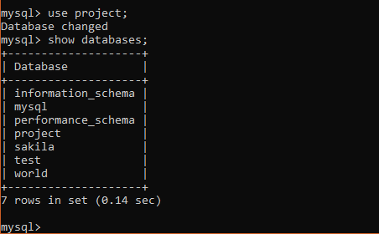

Table names : hospital and ward
hospital table
in this program I used two tables hospital and ward table. Hospital table contains two variables hname and hadd.
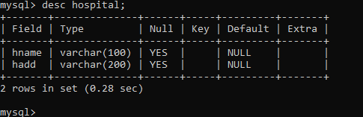

ward table
ward table contains many variables like: id, wname, total_beds, used_beds, available_beds. id variable is the PRIMARY KEY of ward table and it is auto increment.

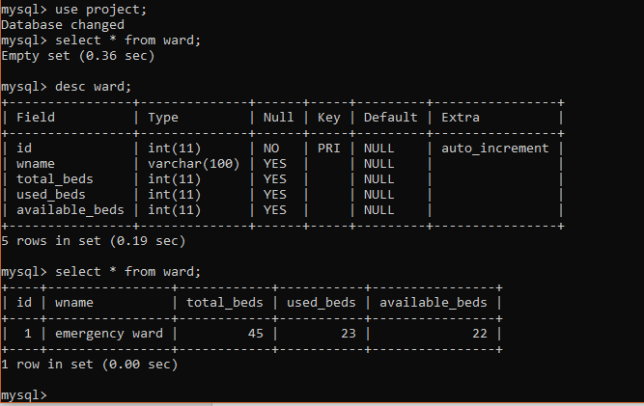

CHAPTER 6
TESTING

6.1 What Is Testing?

Software testing is a specialized discipline in the process of software development.

- Testing is the process of demonstrating that errors are not present.
- The purpose of testing is to show that a program performs its intended functions correctly.
- Testing is the process of establishing confidence that a program does what it is supposed to do.

Levels of Testing

There are three levels of testing:

Unit Testing

Unit testing is the process of taking a module and running it in isolation from the rest of the software product by using prepared test cases and comparing actual results with the results predicted by the specifications and design of the Module. As we use waterfall model for designing our software thus we perform unit testing side by side after coding every individual module.

Integration Testing

We perform integration testing using bottom up integration and we get positive Results in test.

System Testing

This type of testing is done when the system is ready to execute with full functionality.

Acceptance Testing

This type of testing covers all the test cases applied by the customer and comprises software main parts.
- Alpha Testing
- Beta Testing

Functional Testing

Functional testing also known as black box testing is performed on our project. Here we test the functionality of our program. In functional testing we observe the output for certain input values and it produces positive result.

CHAPTER 7
SCREENSHOTS

Main menu

In this screenshot we can se the menu. This menu has many choices like create ward, All ward status, shift beds, update ward values etc. we can choose our desire choice and can manipulate our data.

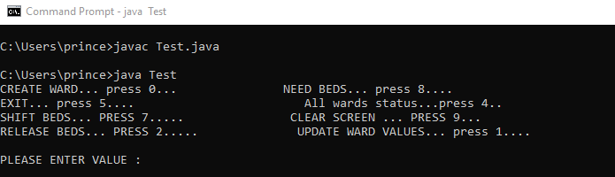

CREATE WARD
we know that there are many wards in a hospital so we can create ward object to press 0. We need to input some values like name of ward, total beds in ward and used beds in ward.
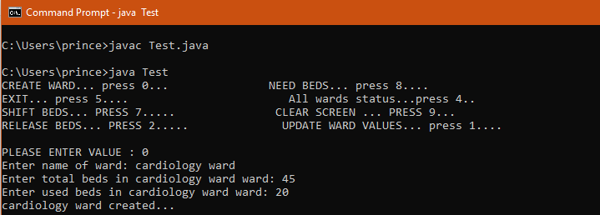

ALL WARD STATUS
If we want to see status of all ward then we need to press 4 and status of all ward will display.

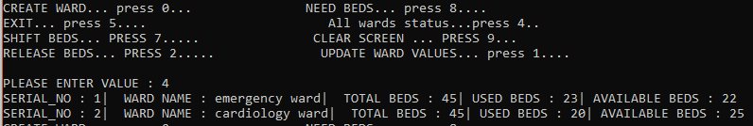

UPDATE WARD VALUES
We wanna update any ward then we need to press 1 and click enter then we can edit our desire ward.
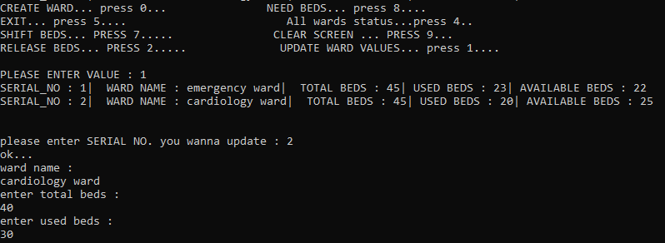

SHIFT BEDS
If we want to shift beds we need to press 7 and then we can shift beds.
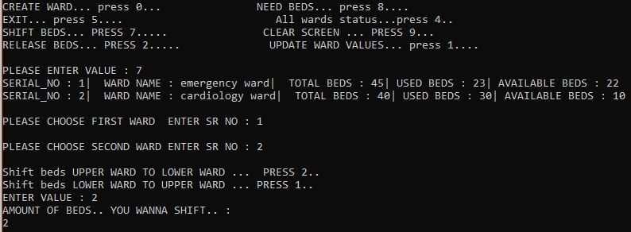

RELEASE BEDS
IF patent will fire at hospital then we need to release bed to press 2
.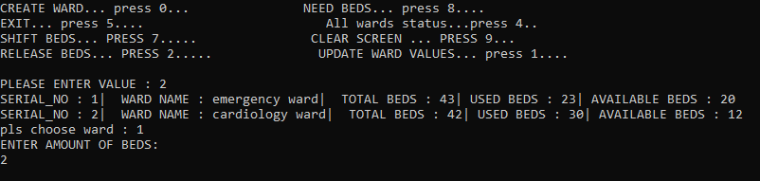

EXIT
PRESS 5 FOR EXIT…
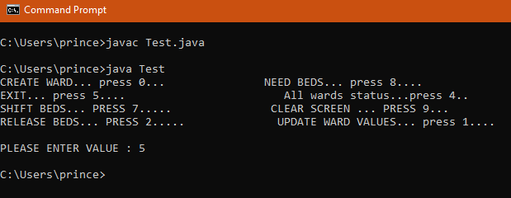

CLEAN CONSOLE
For clear screen press 9.
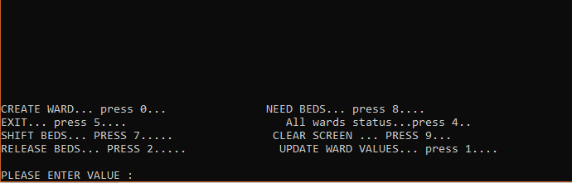

DATABASE

CHAPTER 8

CONCLUSION & FUTURE SCOPE

Hospitals face the permanent challenge of managing resources. By redirecting improve mentactions toward system constraints, actions are adopted so that these constraints affect the systemas little as possible. In the current study, bed availability was the starting point for specific management actions. In particular, the current study preliminarily applied TOC concepts(especially the CRT tool) to increase an understanding the major UEs concerning low bed availability within a private hospital in the metropolitan region of Porto Alegre, Rio Grande doSul.Using the TOC for the current study hospital helped form the basis for improving hospital bed management processes and (especially) increasing understanding among the organisation staff with regard to operational functions and the existing constraints that cause problems in the system.This theme should be studied further using TOC TP with regard to the processes related to low bed availability. Furthermore, other hospital sectors should be addressed, thereby creating atradition of identifying issues and performing structured analysis for problem solving.

CHAPTER 9
REFERENCES

- https://stackoverflow.com/
- https://dzone.com/java-jdk-development-tutorials-tools-news
- https://docs.oracle.com/en/java/javase/12/
- https://leetcode.com/
- https://www.javatpoint.com/java-tutorial
- https://www.geeksforgeeks.org/java/
- https://en.wikipedia.org/wiki/Java_(programming_language)
- https://www.w3schools.com/java/
- https://www.guru99.com/java-tutorial.html
- https://www.journaldev.com/7153/core-java-tutorial

